2023 IFFS World Congress
Exploring New Horizons in Fertility Care

The IFFS World Congress provides a unique platform for attendees to convene, learn and discuss current advances in reproductive health, access to fertility care, and reproductive rights across the globe, and engage the patient perspective. The theme of the 2023 IFFS World Congress is "Exploring New Horizons in Fertility Care”. Keynote lectures, panels, and our signature trilogy sessions will focus on innovations in male and female infertility, ART, clinical embryology, reproductive genetics, cross-border and third-party reproduction, endometriosis, adenomyosis, fibroids, endoscopic surgery, contraception, gynecological imaging, reproductive environmental health, menopause, and the patient perspective. Renowned international faculty will engage attendees, while free communications and poster sessions offer an opportunity to share cutting edge research and explore new ideas.

The congress will take place in Athens, Greece,
at the Megaron International Conference Centre
10-13 September 2023.

Important Dates:
- Abstracts can be submitted until April 30th, 2023
- Early bird registration deadline is June 30th, 2023

For further information about the Congress you can visit:
IFFS World Congress 2023
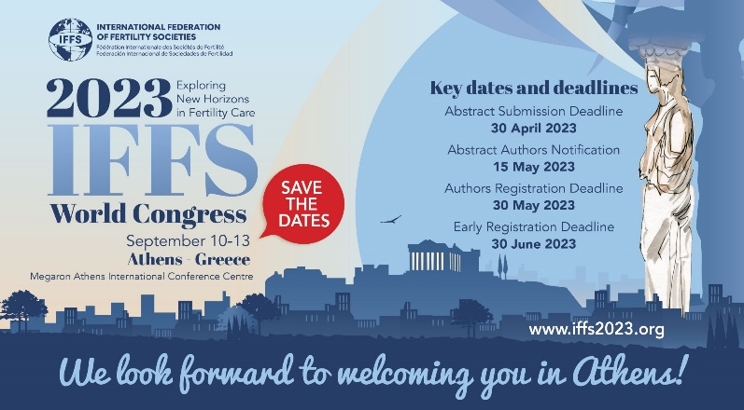
On behalf of the Organizing & Scientific Committee,
Linda C. Giudice, MD, PhD, IFFS World Congress Chair
Bart Fauser, MD, PhD, IFFS Scientific Director
Basil Tarlatzis, MD, PhD, Director, Local Organizing Committee

