FEDERATION OF REPRODUCTIVE HEALTH ASSOCIATIONS, MALAYSIA
OGSM BASIC CONTRACEPTION COURSE

DATE : 12th January 2019
TIME : 8.00am – 5.00pm
VENUE : Federation of Reproductive Health Associations, Malaysia
CONTACT NO : 03- 556337514 /16/ 28 (Ms Jenell)
CPD POINTS : 6 Points (A3)
COURSE FEE : RM 120 (Doctor / Pharmacist)
RM 80 (Nurse/ Paramedic)

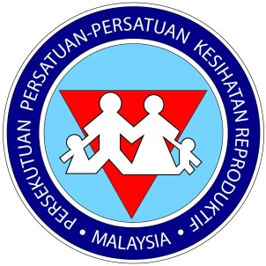
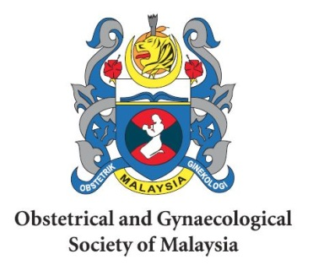
Organized by: In Collaboration with:

